# /Users/frca/Desktop/Logos/frca.logo.pdf Newsletter Jan/Feb 2018

# 

# 

# Let’s Rock

January, as is tradition, began with the Let's Rock event alongside our regional friends from Remarkable Arts, Castaway and Junction Goole at Bridlington Spa.

Crammed with cracking performances from a wide range of young people, the event was, as ever, inspiring for those involved, and for those in attendance, a great way to ROCK into 2018.

As the event was such a success with standout performances across the board, we think everyone deserves a special shout out:

So; Courtney, Dan, Danielle, Dom, Dylan, Ellie, Emily C, Emily S, Ethan, Gracie, Jacob, Lucy, Ollie, Sam, Ty, Amber, Isabel, Jake, Jamie, Jayde, Josie, Kaomi, Leila, Matthew, Natasha, Phoebe, Rachel, Shelley, Nicole and Carrie (hope I've not missed anyone)...WELL DONE!!!!

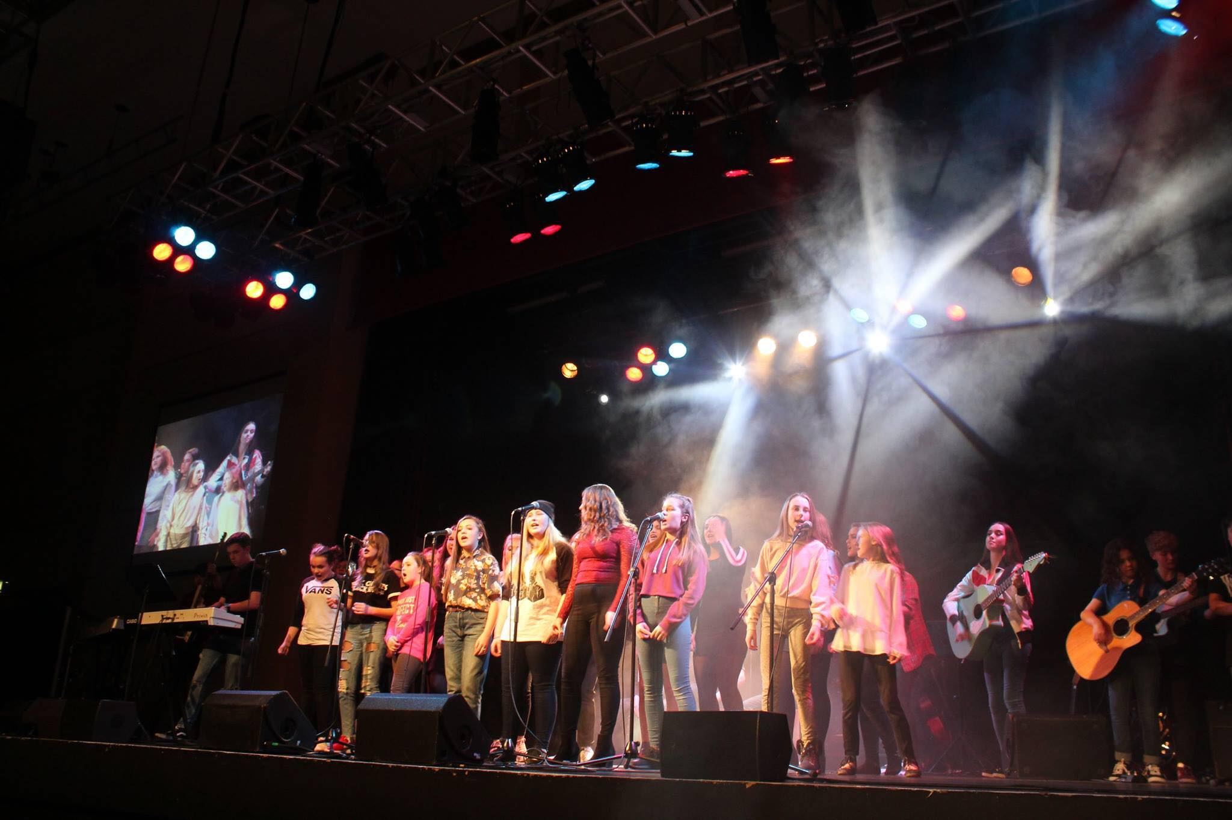

Musical Theatre Review Performance

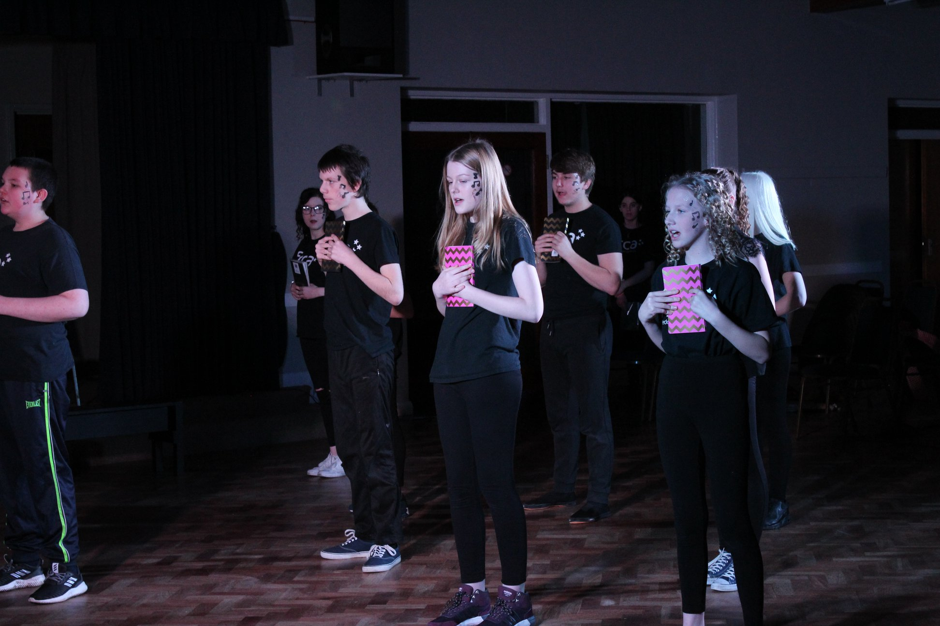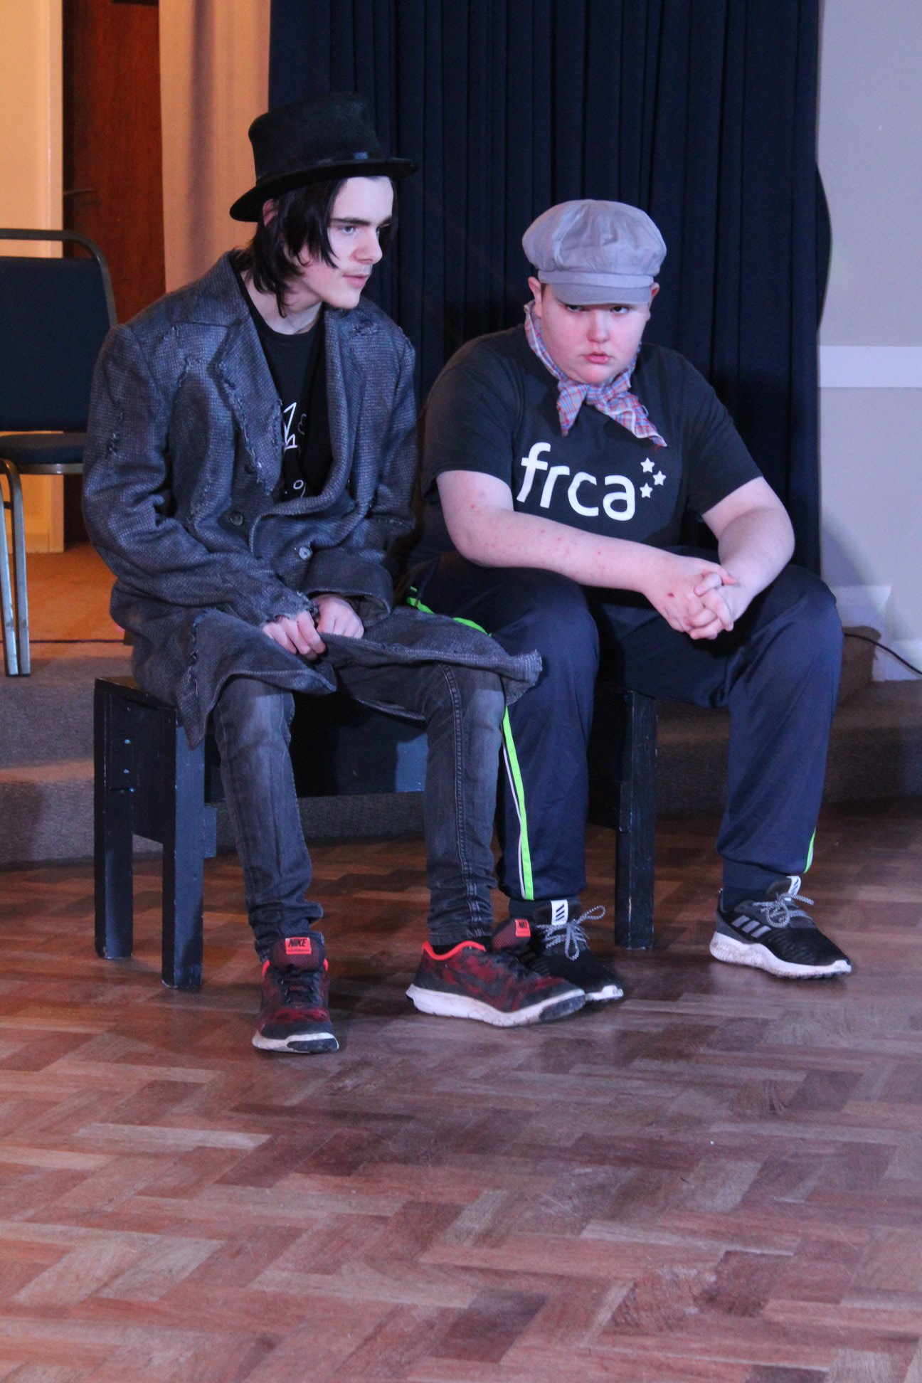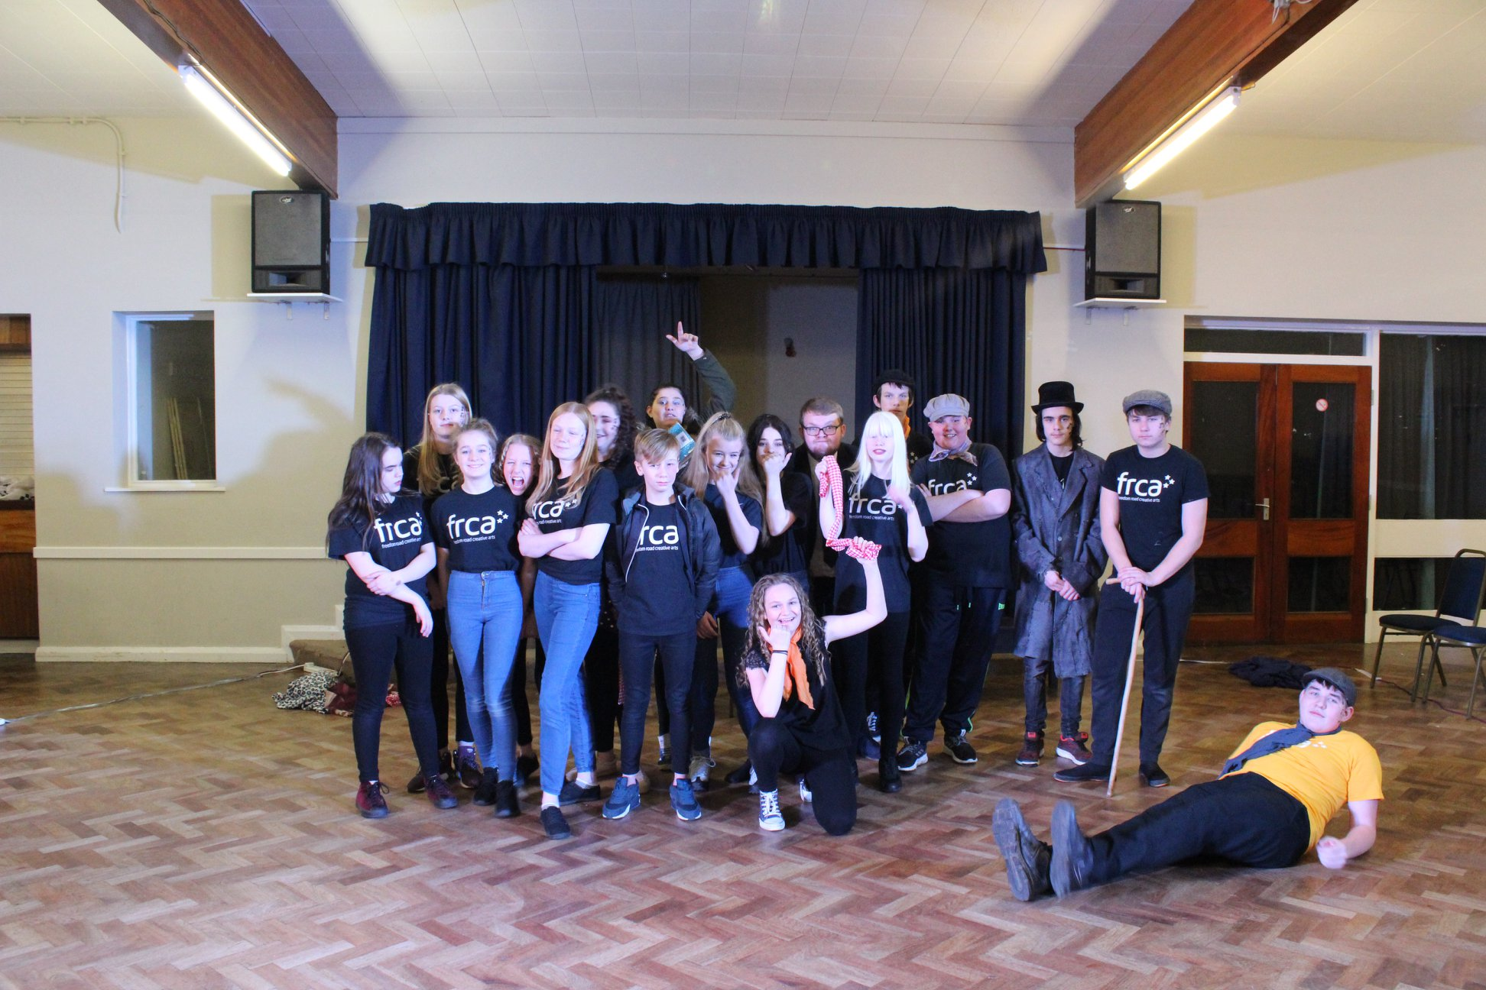

Our 3rd February Musical Theatre Review Performance took place at Marist Church Hall, where we performed scenes from the classics; Oliver, Matilda and Annie.

Thanks to all those who came to watch and support the event and of course to the talented young people involved. We hope we offered a snippet of just what can be achieved in a short period of time.

Royal Shakespeare Company Workshops

Working with the Royal Shakespeare Company and Creative Voice, a lucky handful of young people at FRCA participated in a drama workshop at Hull New Theatre. This included a range of team-building drama exercises conducted by Alex from RSC and concluded in a performance of an excerpt of Hamlet. A fun and unique way to engage with Shakespeare, and all in just one day!

A big thanks to Ruth Drake at Creative Voice for organising this. A fantastic experience for all those involved.

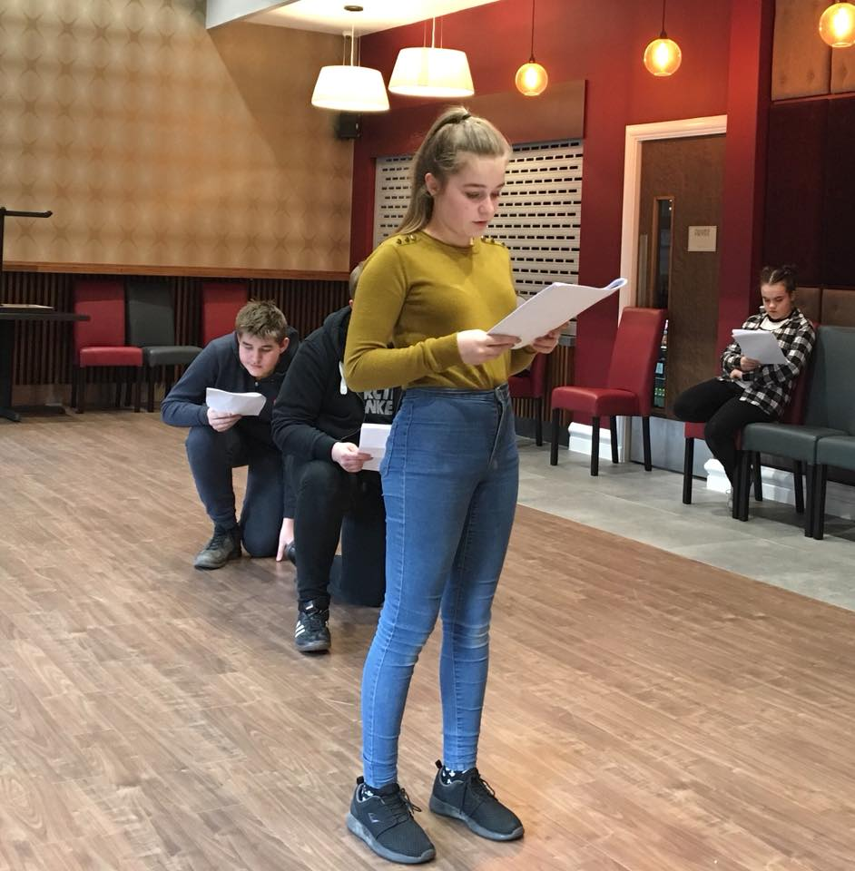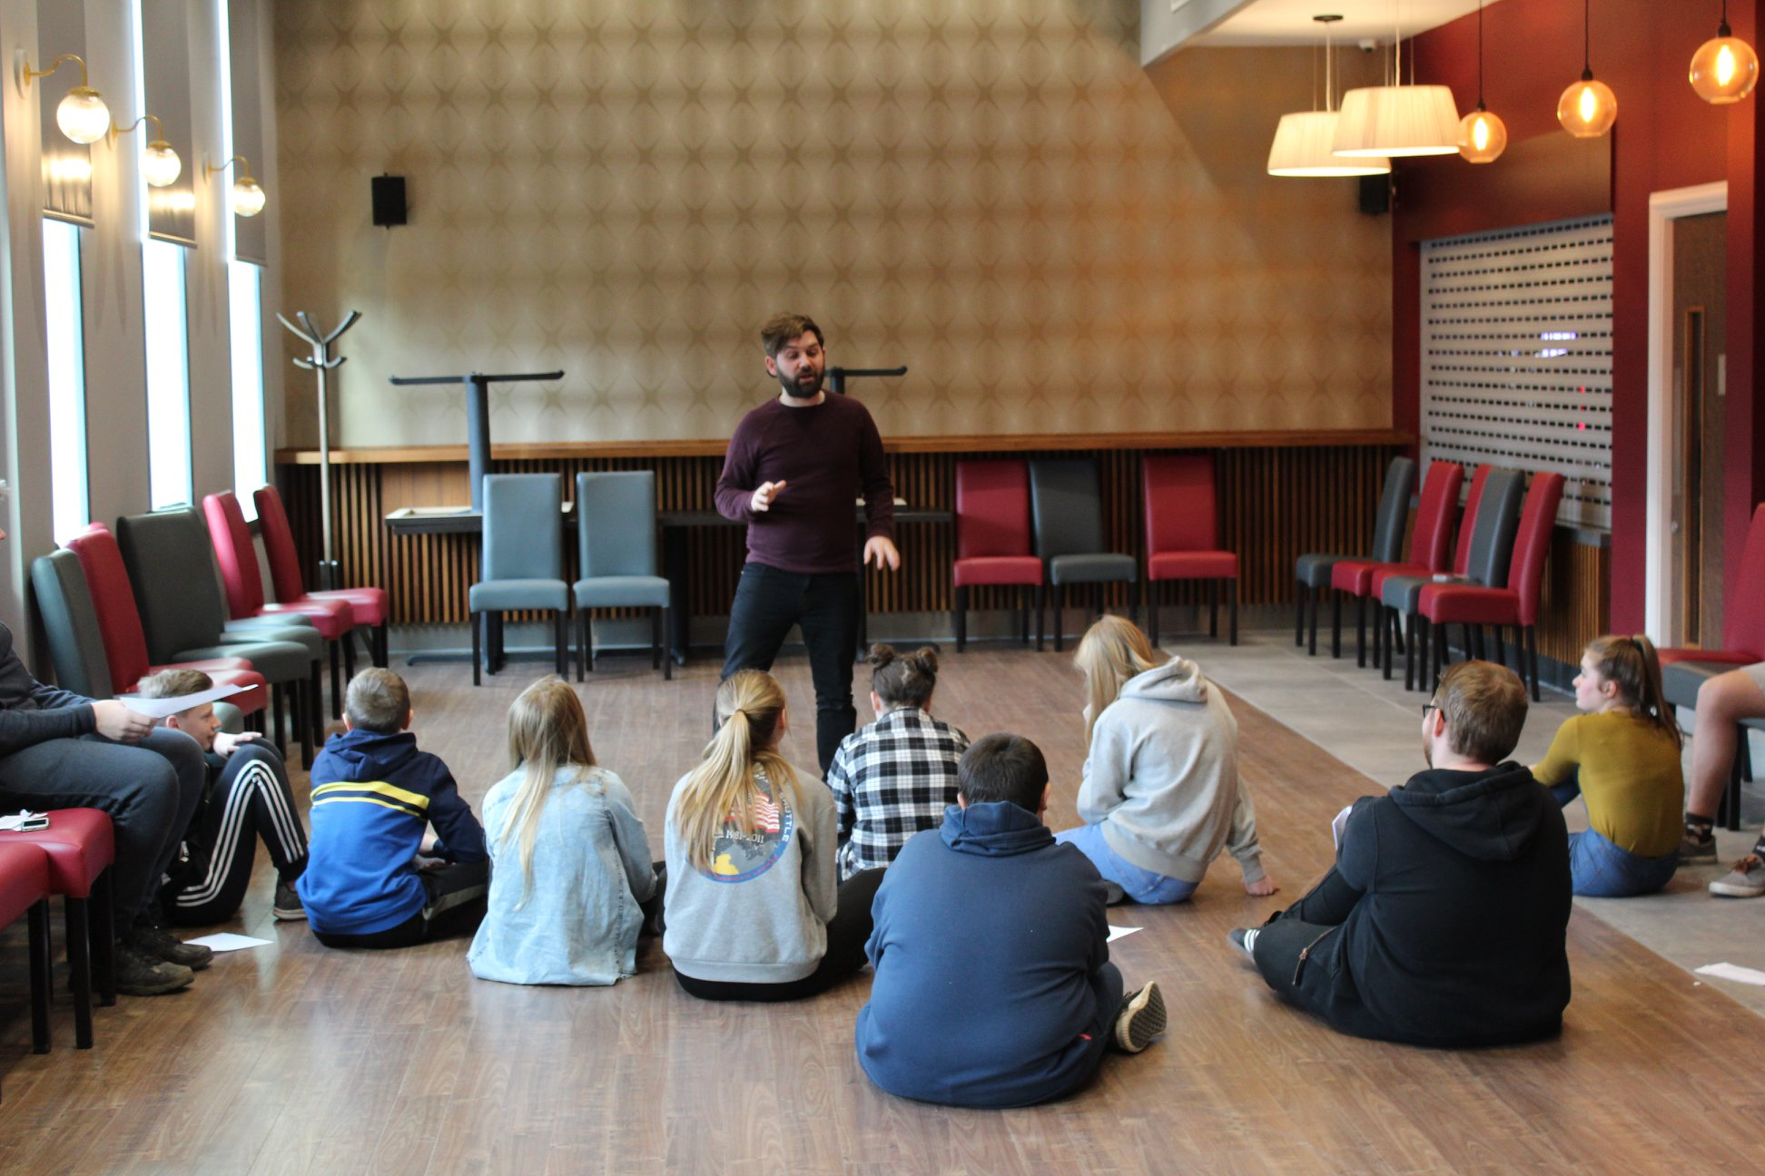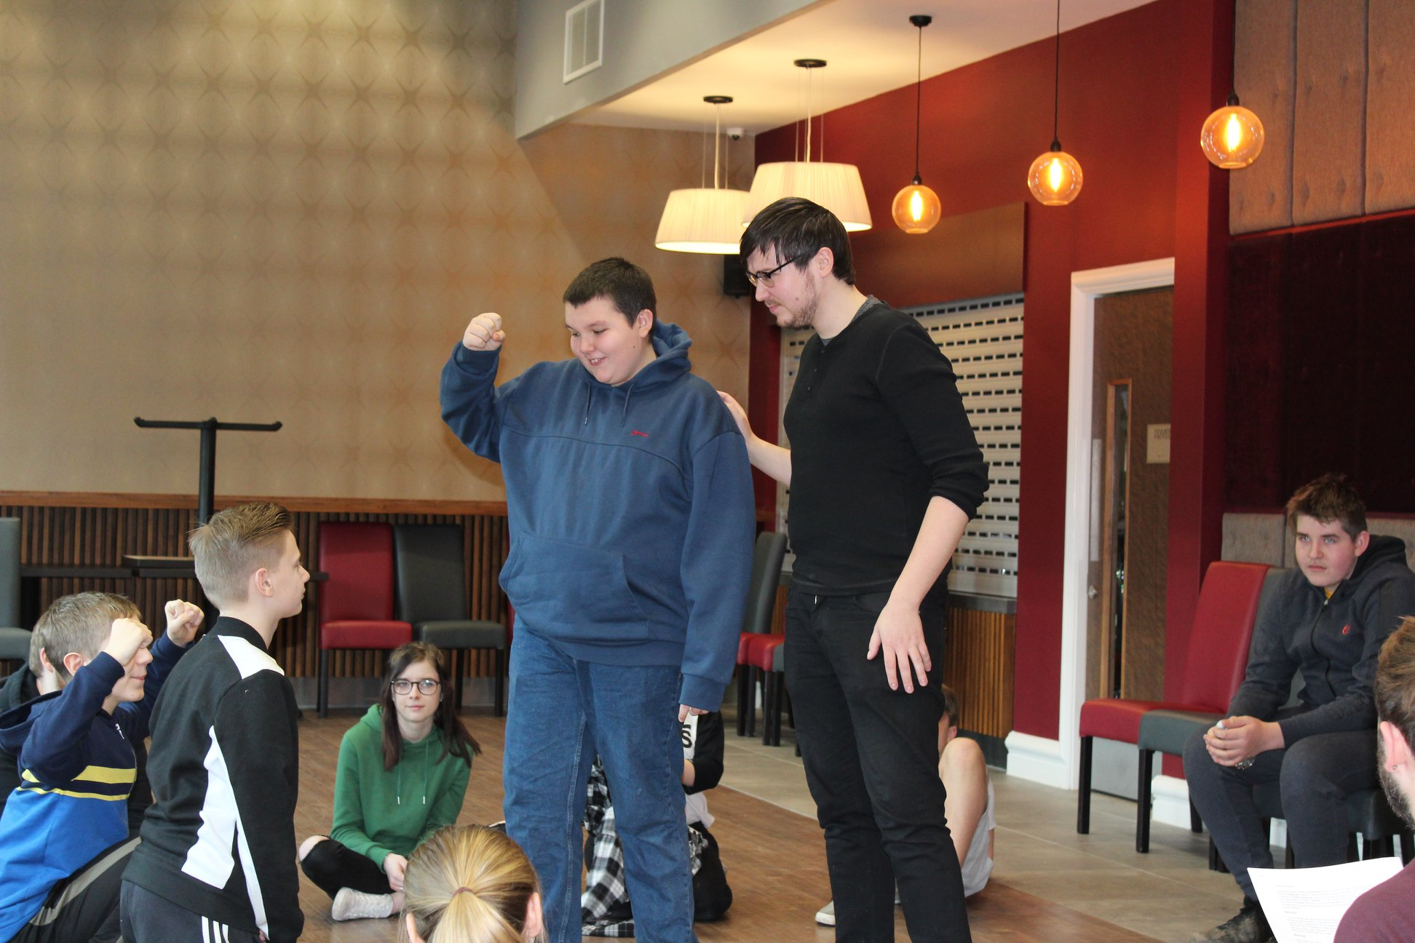

What’s coming up in March?  
**Two gigs for our Headstart funded "Hull's Music History" project take place on;**

* **Saturday 10th March** - *at O'Reily's, Beverley Road from 7pm.*
* **Wednesday 21st March** - *at Kardomah 94 from 7pm.*

Young People involved have recreated an array of songs from famous local artists such as Fatboy Slim (Norman Cook), The Beautiful South, The Housemartins and Mandy and the Girlfriends.

**ITS FREE ENTRY AND NOT TO BE MISSED!!!**

Now time for our monthly interview segment:

A Focus on – **Dylan Burton**

**Hello Dylan. What are you involved in with FRCA?**Saturday music group at Kardomah and usually Tuesdays at Kingston Youth centre, but I’m currently involved in a project at Kardomah on Tuesdays.

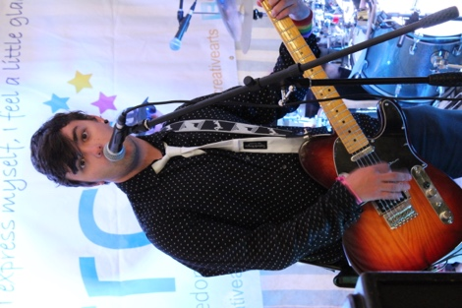  
**What instruments do you play?**  
My main instrument is guitar, but I play bass for FRCA.

**Tell us a bit about your band ‘Unwired Society’:**We’re a punk rock trio band. We make songs that are relatable and speak a message. I sing and play guitar and write the lyrics in the band.

**What has been your favourite gig with FRCA?**Either Cottingham Springboard or Tribfest.

**Who are your musical influences?**Green Day, Angels and Airwaves, The Clash, U2, Ramones and Blink 182

**What are you doing at college?**Level 3 Music Tech.

**What would be your ideal career?**Musician/Producer

**THANKS DYLAN, WE’LL HAVE ANOTHER INTERVIEW WITH A TALENTED YOUNG PERSON NEXT MONTH. STAY TUNED!**

Additional News at FRCA:  
**Ty Rokahr** has released another single “Dogs” which is available via his youtube site *https://www.youtube.com/channel/UCQyWl-imXVI1k44h5dqV9vQ* –and **Elizabeth Pickering** was at last featured on BBC Humberside Introducing. Good stuff from 2 young artists who we have had the pleasure of working with over the years.

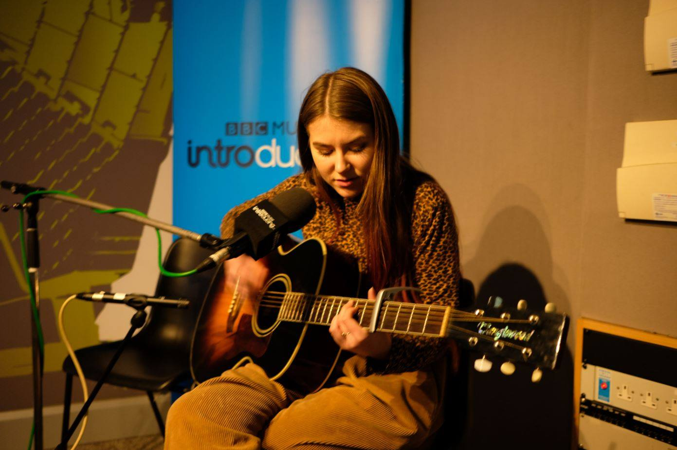

***How to get involved***

For more info on FRCA and to find out more about the sessions we run, or details about any future performances please get in touch via,  

*Email-* Info@freedomroadcreativearts

*Telephone-* 07921800617

Facebook – Freedom Road Creative Arts Twitter @FRCarts